CNDC PROJECT

Project By:

Fahad Iqbal (2012379)

Faseeh Shahid (2012390)

Ali Zafar Qureshi (2012374)

Syeda Sara Naqvi (2012411)

Introduction:

The advancement of technology and the increasing reliance on interconnected systems have made networking infrastructure an essential component for organizations of all sizes. In line with this requirement, the task at hand is to design and implement a networking infrastructure for the SZABIST Karachi campus. This project aims to provide a robust and efficient network solution that caters to the diverse needs of multiple departments operating across seven different buildings within the campus.

The primary objective of this project is to create a comprehensive networking infrastructure that seamlessly connects various departments, labs, classrooms, and administrative areas within the SZABIST Karachi campus. By doing so, it will enable efficient communication, data sharing, and resource utilization while ensuring a secure and reliable network environment for the entire campus.

To achieve this goal, careful consideration must be given to the specific requirements of each building and department within the campus. The project scenario provides detailed information on the devices present in each building, including PCs, printers, servers, and other network components. Additionally, the scenario emphasizes the need for IP address management, VLAN implementation, inter-VLAN routing, DHCP configuration, and port security.

Furthermore, this project report will present a detailed diagram illustrating the proposed networking infrastructure for SZABIST Karachi campus. The diagram will showcase the internal network, highlighting the connectivity between different devices, departments, and buildings. Each element of the diagram will be clearly labeled, ensuring a comprehensive understanding of the network architecture.

By successfully designing and implementing this networking infrastructure, SZABIST Karachi campus will benefit from improved connectivity, enhanced network management, and streamlined communication. Faculty members, students, and administrative staff will experience a more efficient and reliable network environment that supports their academic and administrative activities.

In the following sections of this project report, we will delve into the detailed design and implementation aspects of the networking infrastructure, addressing each building's requirements, IP addressing schemes, VLAN configurations, routing protocols, security measures, and remote management capabilities. The report aims to provide a comprehensive blueprint for the successful deployment of the proposed networking solution, enabling SZABIST Karachi campus to meet its networking needs effectively.

Topology:

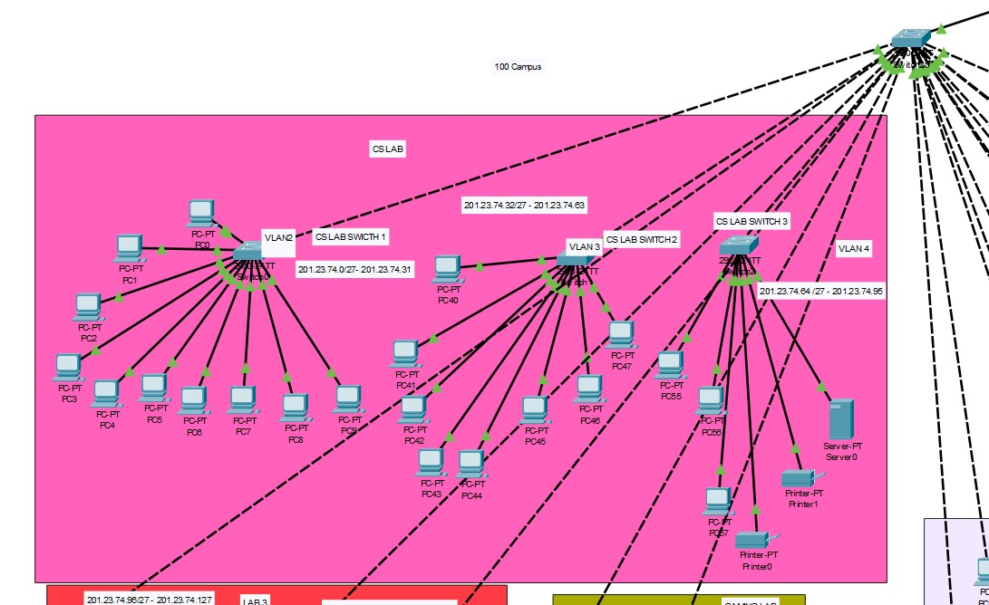

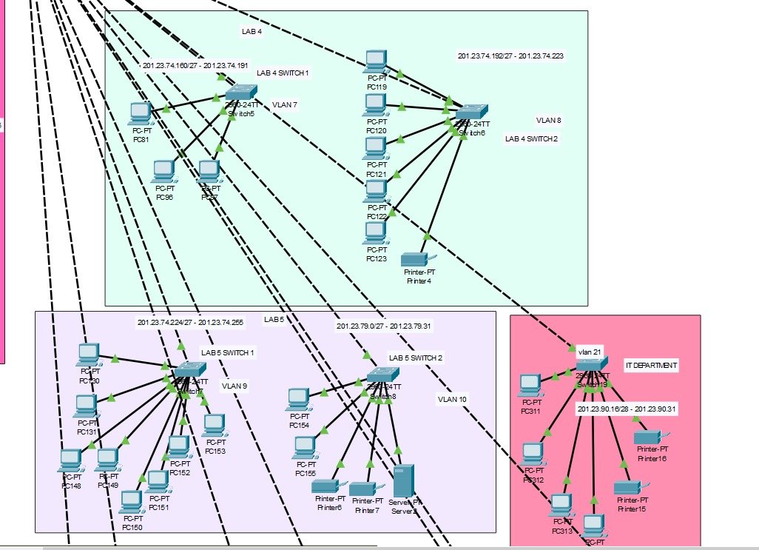

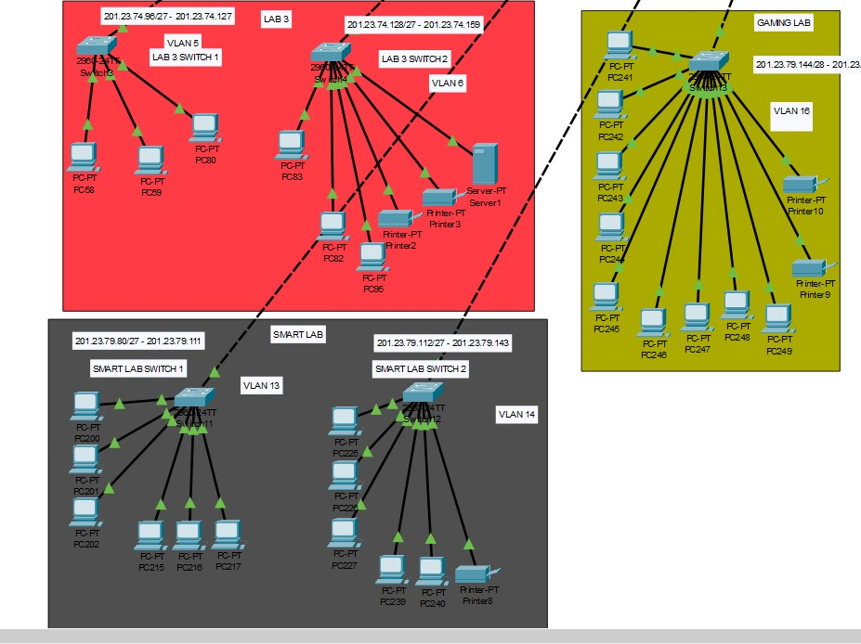

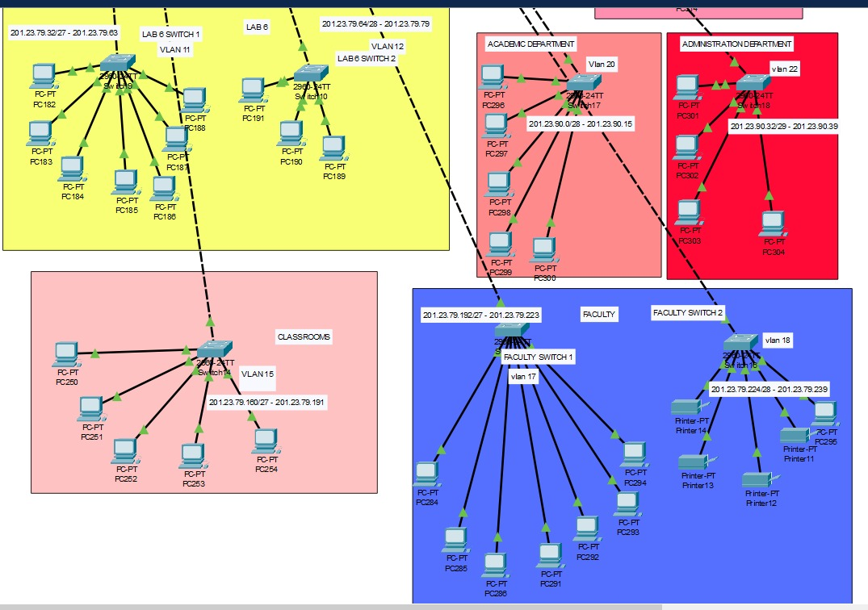

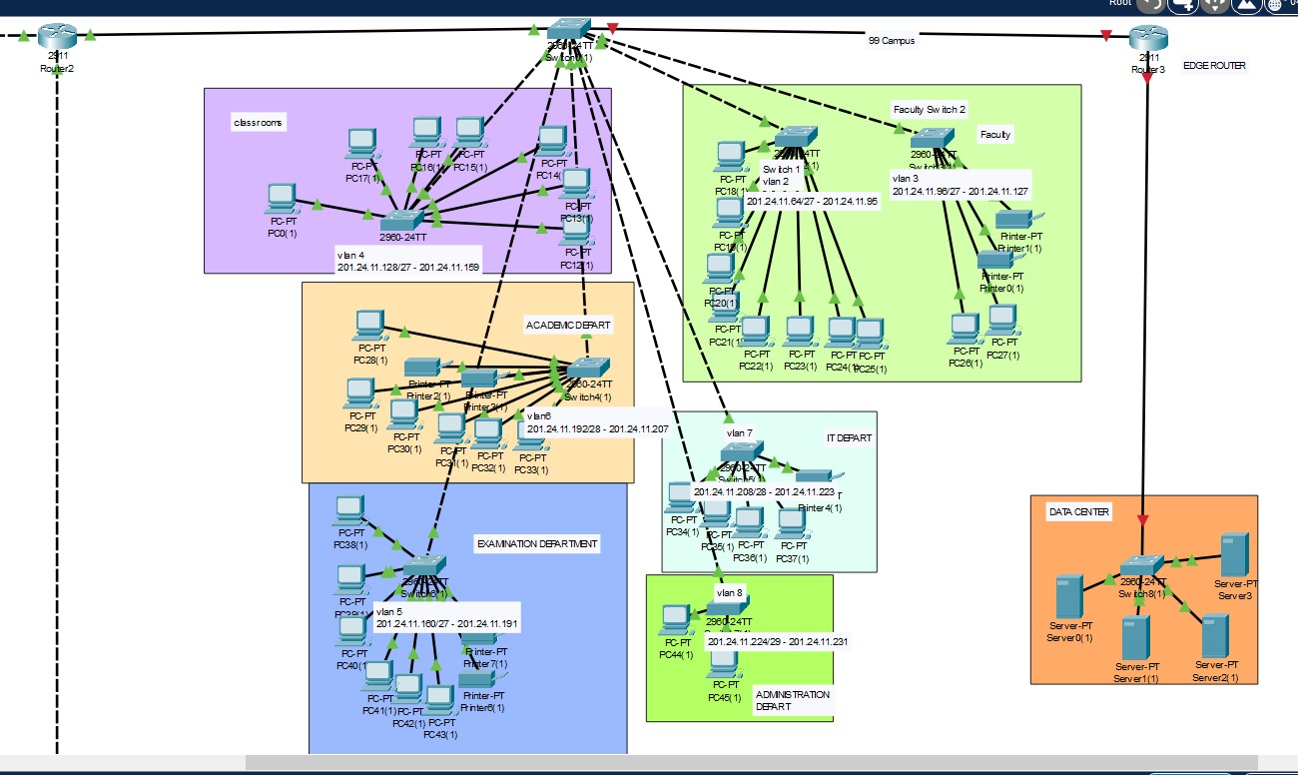

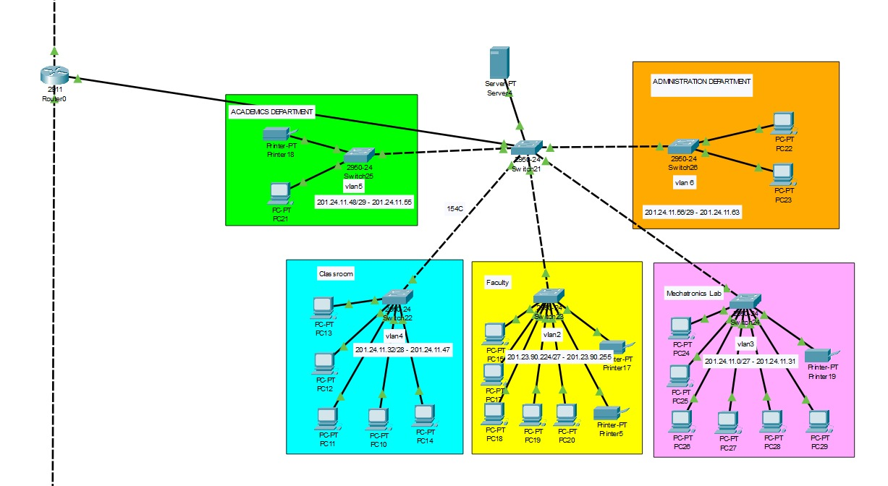

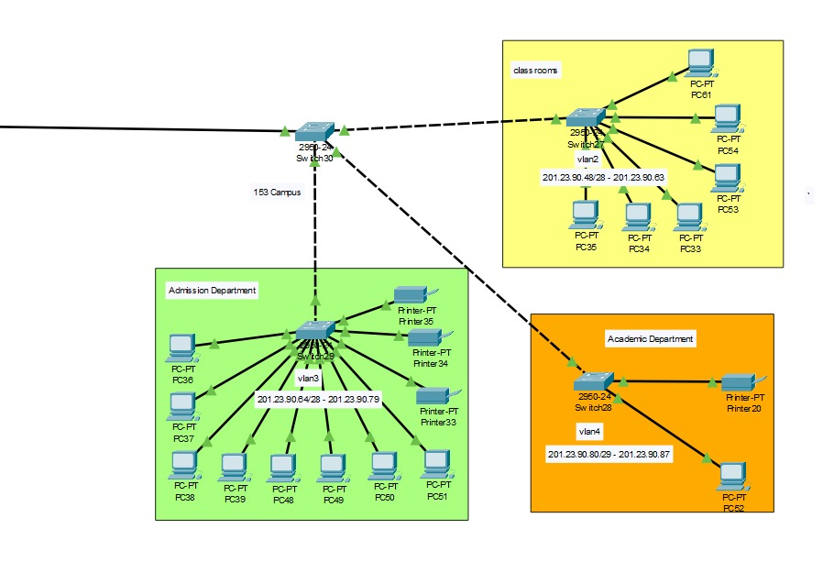

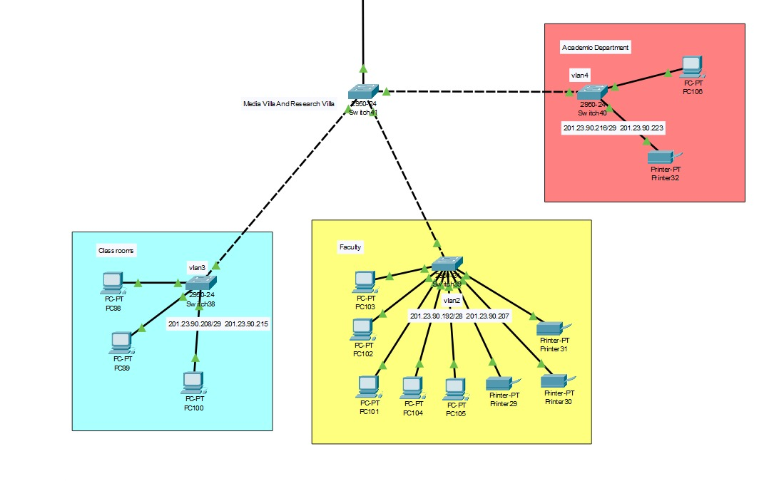

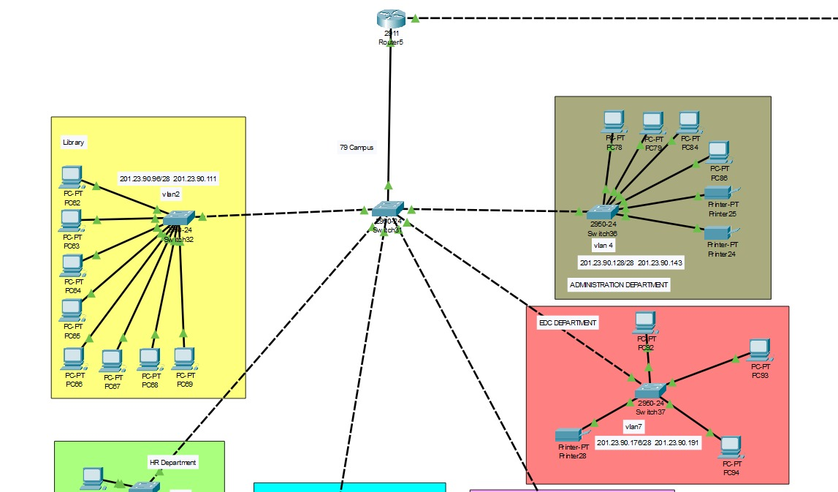

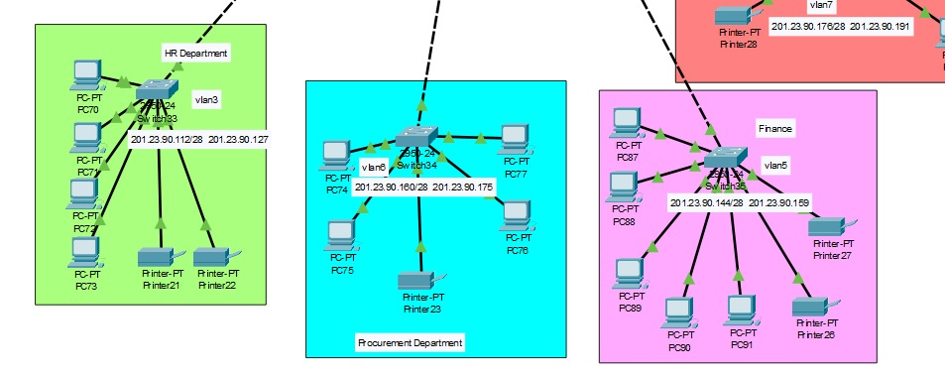

Full Topology:

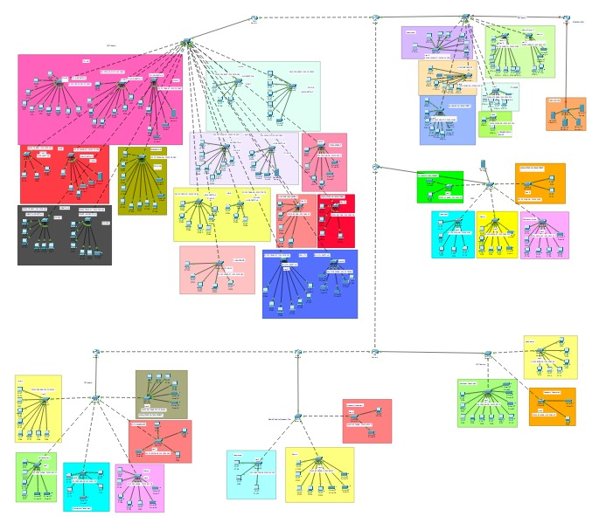

Sub-netting:

100 Campus:

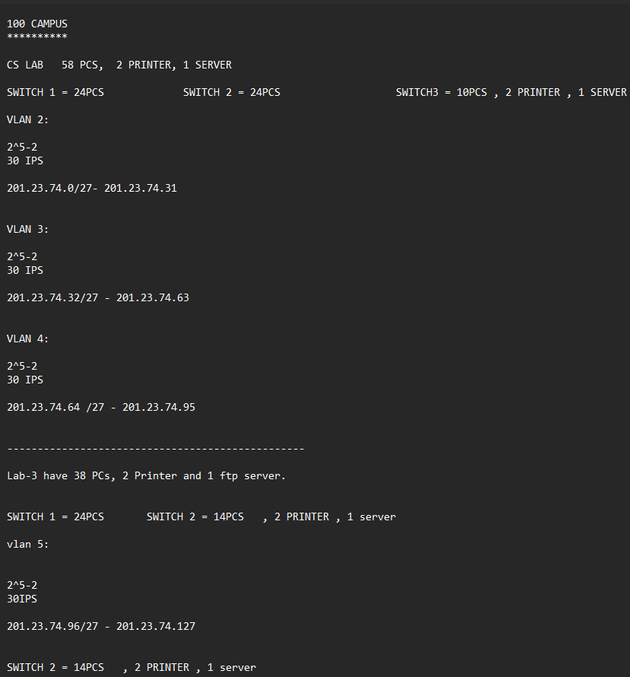

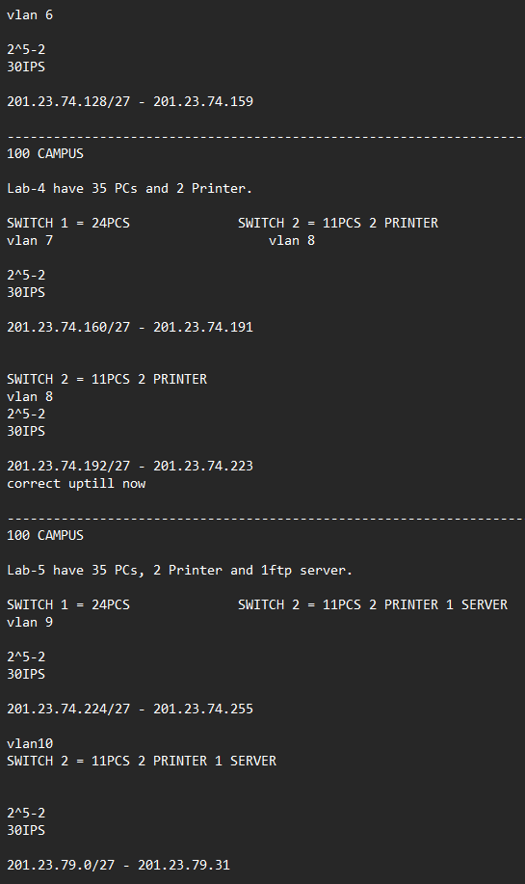

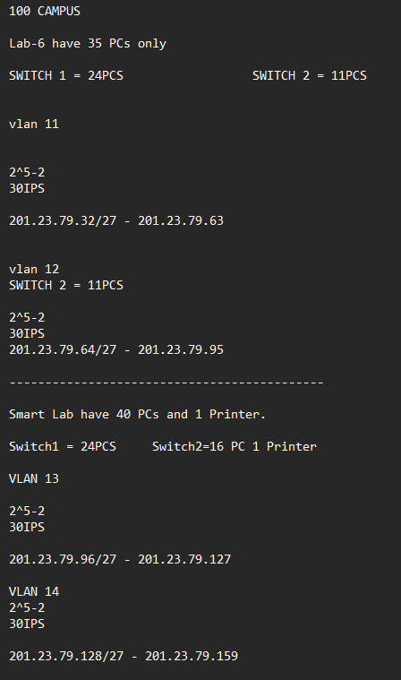

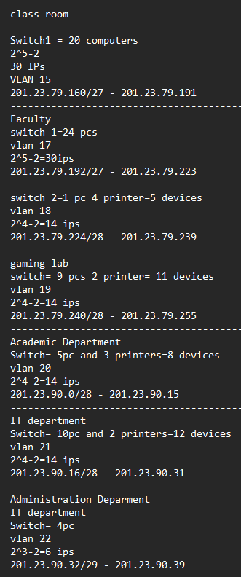

99 Campus:

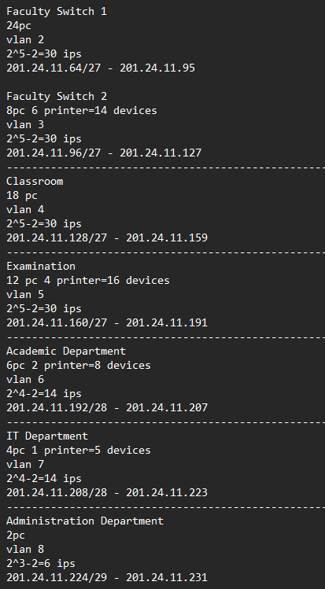

154 Campus:

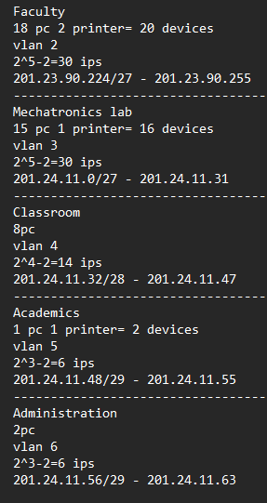

153 Campus:

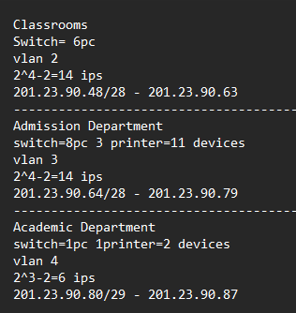

79 Campus:

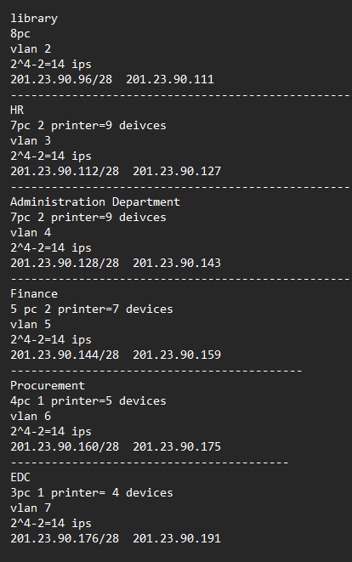

Media Villa and Research Villa:

